# How To Broadcast Your First Live Stream On WordPress With Hapity

In this article, you'll learn how to create your first Hapity live broadcast on your WordPress site with simple step-by-step instructions. After just a few minutes, you'll have a working live stream that your visitors can watch.

[embed video version of this here]

## Step 1: Create Your Free Hapity Account

To get started, create your free Hapity account. [Go to the registration page](https://www.hapity.com/register) and enter your desired login credentials. Or, you can also sign in with Facebook or Twitter:

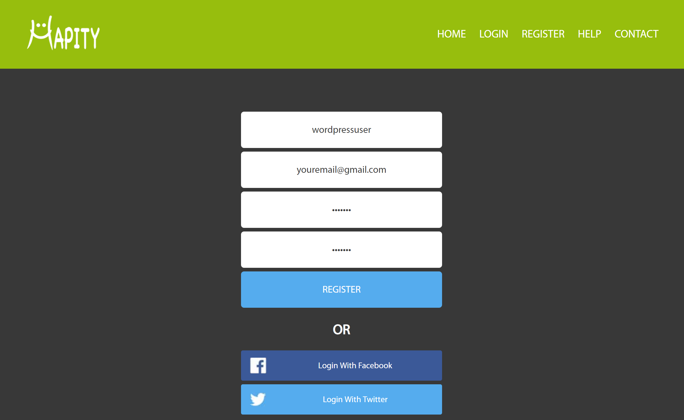

WordPress-1

## Step 2: Install And Activate The Free Hapity Plugin

The [Hapity plugin is available for free at WordPress.org](https://wordpress.org/plugins/wp-hapity/), which means that you can install it directly from your WordPress dashboard.

To do that, go to **Plugins → Add New** in your WordPress dashboard. Then, search for "Hapity" and click the **Install Now** button:

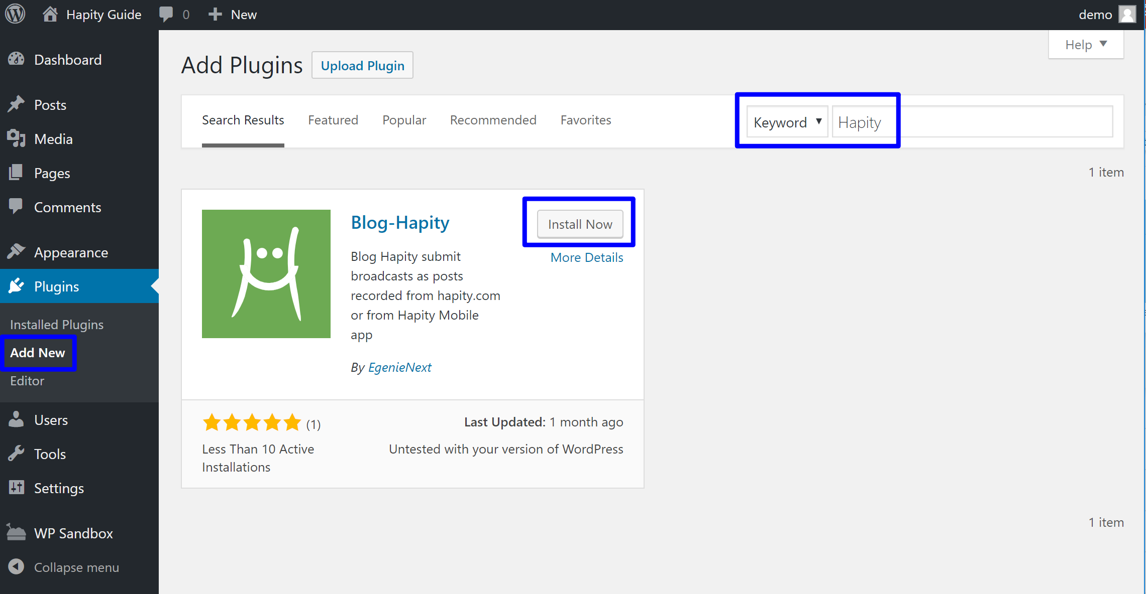

WordPress-2

While your WordPress site installs the plugin for you (it should only take a few moments) you should see an **Activate** button appear in place of the **Install Now** button. Click that button to activate the Hapity plugin on your site:

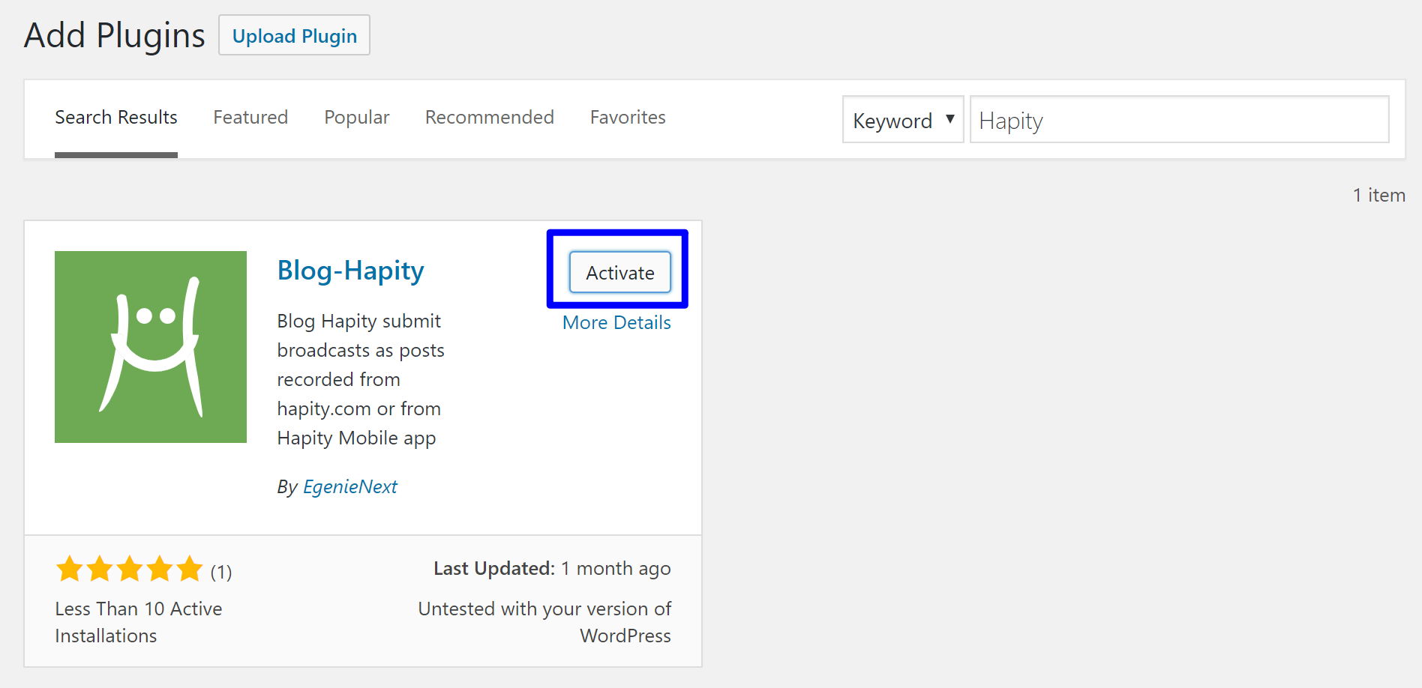

WordPress-3

## Step 3: Add Hapity Auth ID To Plugin

In order to connect your Hapity account to the plugin on your WordPress site, you'll use something called an "Auth ID" to link the two together.

To find your Auth ID, [log in to your Hapity account](https://www.hapity.com/home/login) and click on **Settings** in the top-right corner:

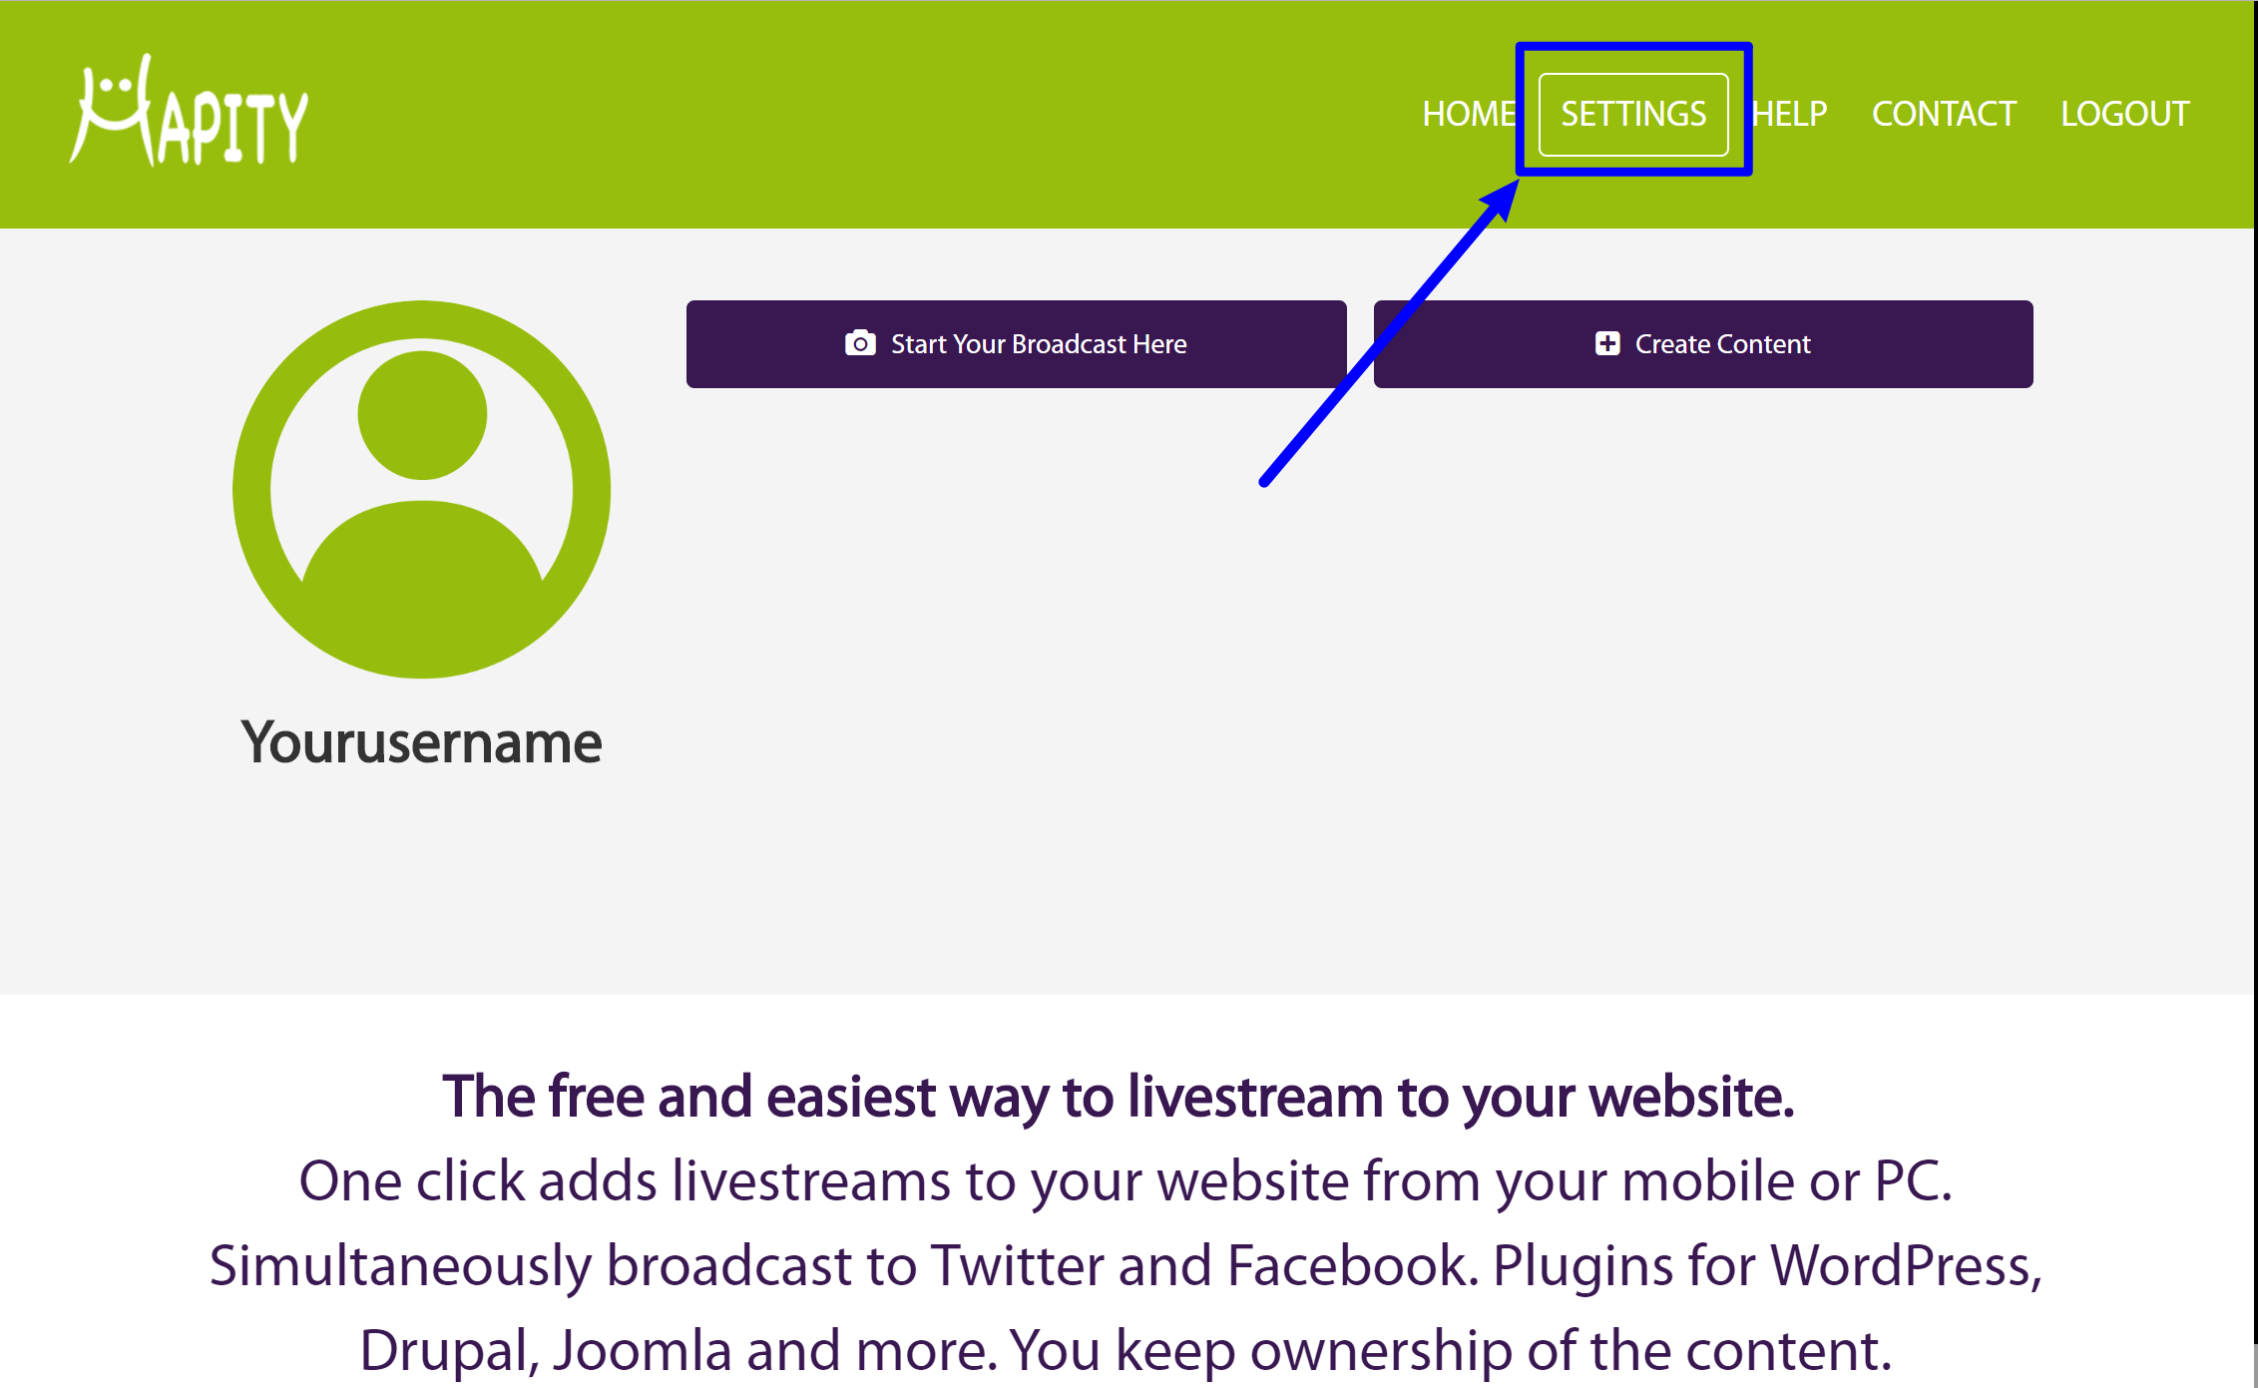

WordPress-4

Then, scroll down and find the box for **Plugin ID**, which contains a long string of numbers and letters. Copy the value in this box:

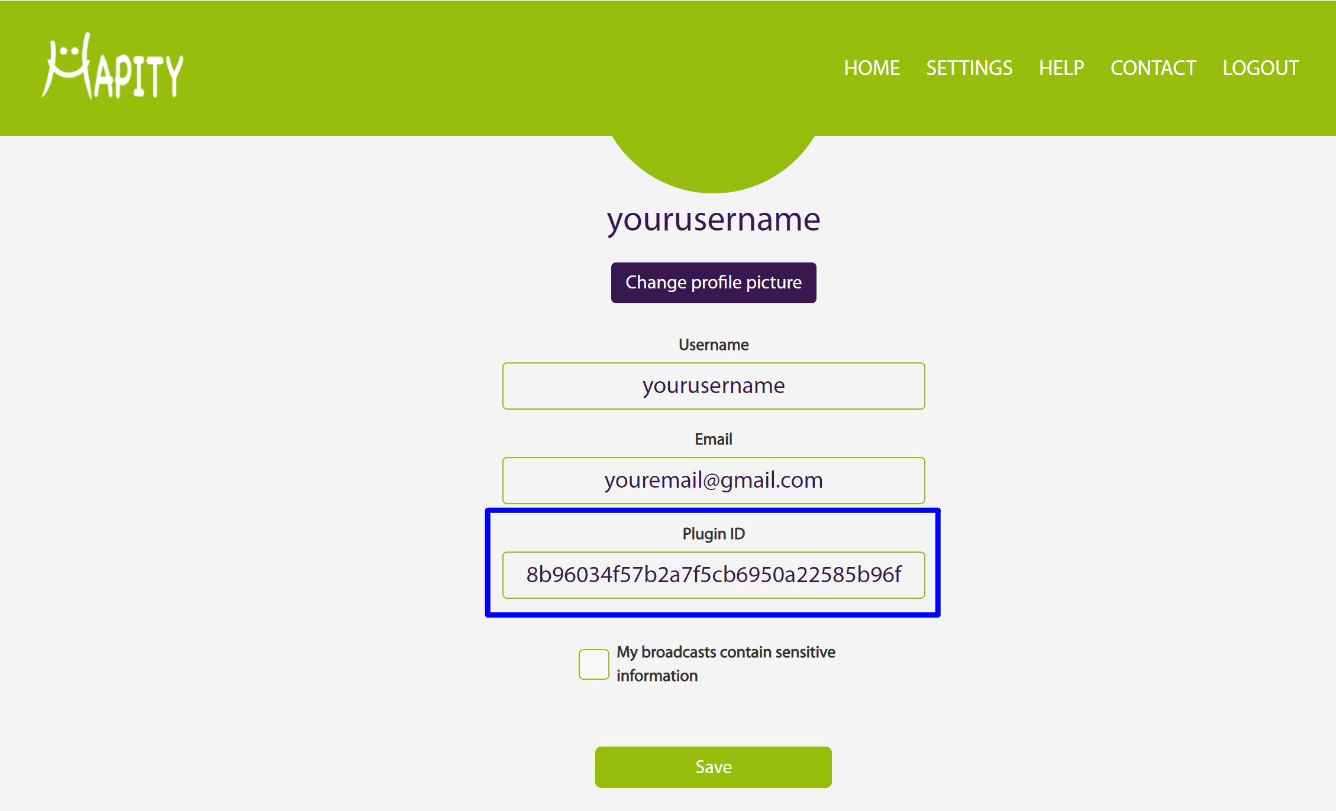

WordPress-5

Once you've copied the **Plugin ID**, go to your WordPress site's dashboard and click on the **Hapity** option in your WordPress dashboard sidebar.

Then, paste the **Plugin ID** into the box labeled **Enter Your Auth ID** and click the **Authenticate** button:

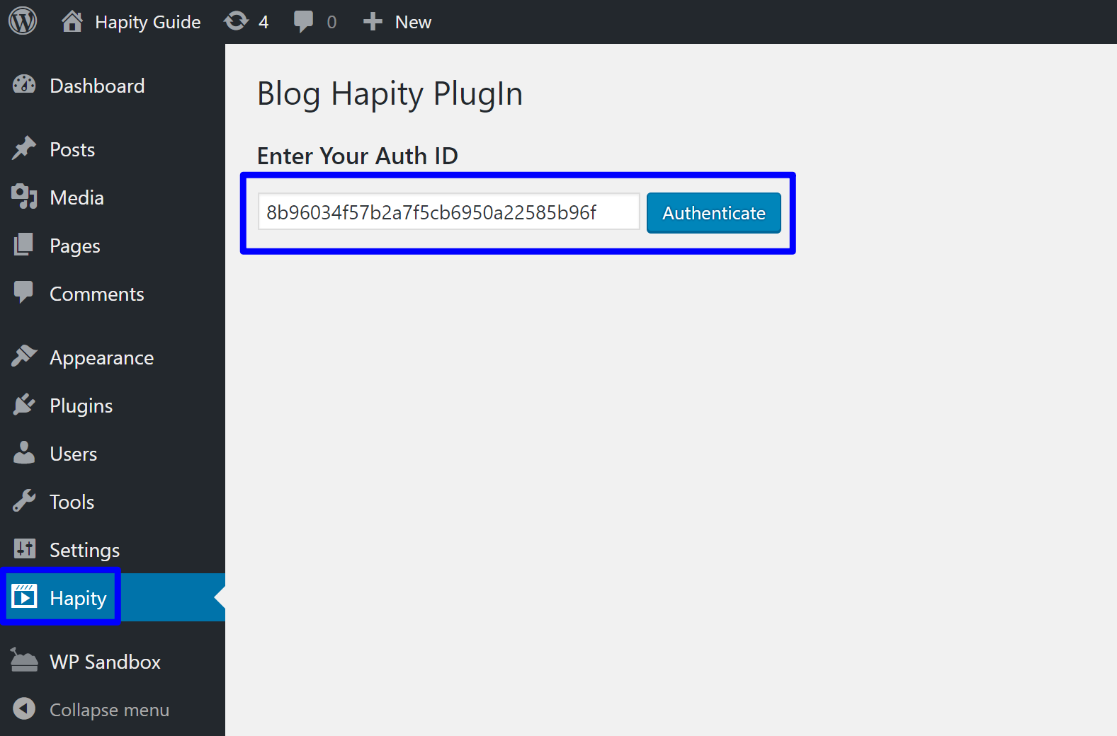

WordPress-6

Once you activate the plugin, you should see a new set of options. By default, Hapity is **Enabled** as soon as you authenticate your Auth ID:

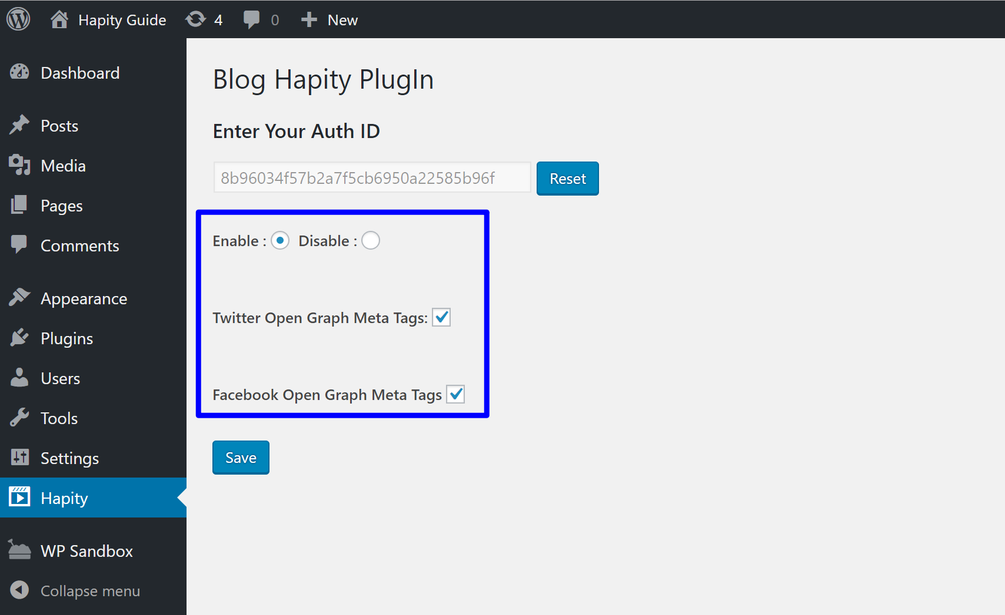

WordPress-7

## Step 4: Broadcast Your First Live Stream

Now you're ready to broadcast your first live stream!

With Hapity, you can broadcast from your:

* Mobile device (iOS or Android)
* Computer

You can share your broadcast before or after on Twitter and Facebook by selecting the appropriate icons; the first time you use these, you’ll be asked to log in. You can also share on other platforms including email, SMS, and Whatsapp.

If using a mobile device, your broadcast will be saved onto this device (find this under Gallery on Android, and Photos on iPhone).

The livestream and data are handled by Hapity servers, so there’s no need to worry about any additional charges for your website hosting. You own all the content you livestream.

### Broadcasting from a mobile device

To broadcast from your mobile device, you'll first need to install the Hapity app from the [Google Play Store (Android devices)](https://play.google.com/store/apps/details?id=com.app.hapity) or [Apple's App Store (iOS devices)](https://itunes.apple.com/jm/app/hapity/id1068976447?mt=8).

When you first open the app, you'll need to sign into your Hapity account. Then, you can click the floating camera icon in the bottom-right corner to start your first broadcast:

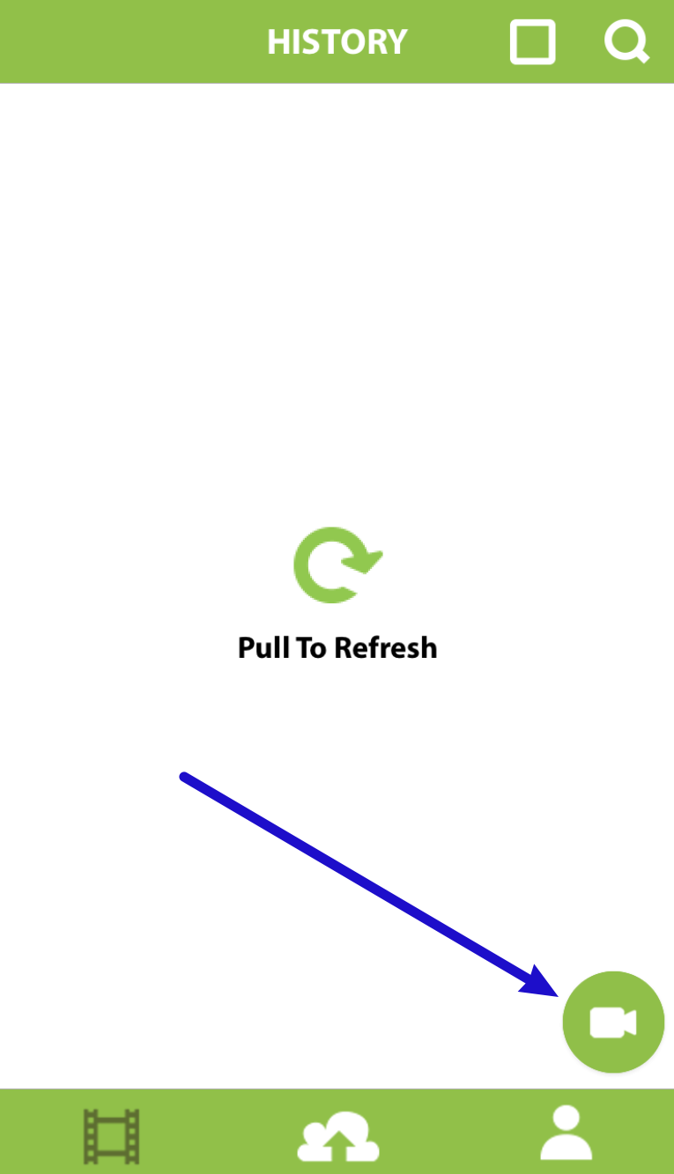

Mobile-1

After clicking that button, you'll need to give Hapity permission to access your device's:

* Camera
* Microphone
* Pictures

*These permissions are necessary to create a broadcast and save the broadcast video to your device.*

Then, you should see the video feed from your device on your screen.

You can give your broadcast a name by typing in the text field. Then, just click the green circle when you're ready to make your broadcast live and available to the public:

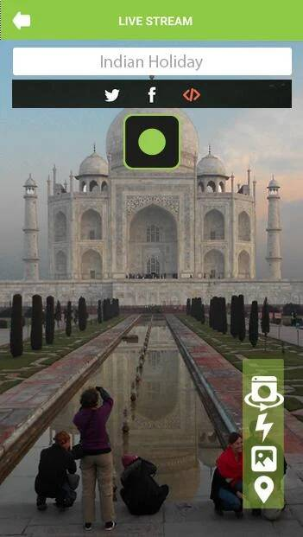

Mobile-2

Once you go live, you'll see a "You Are Live Now" indicator in the bottom-left corner of your screen.

And when you're ready to end your broadcast, all you need to do is click the red circle in the middle of your screen.

### Broadcasting from your computer

If your computer has a web camera, you can live stream straight from the Hapity website. To do that, [log in to your Hapity account](https://www.hapity.com/home/login). Then, click the **Start Your Broadcast Here** button:

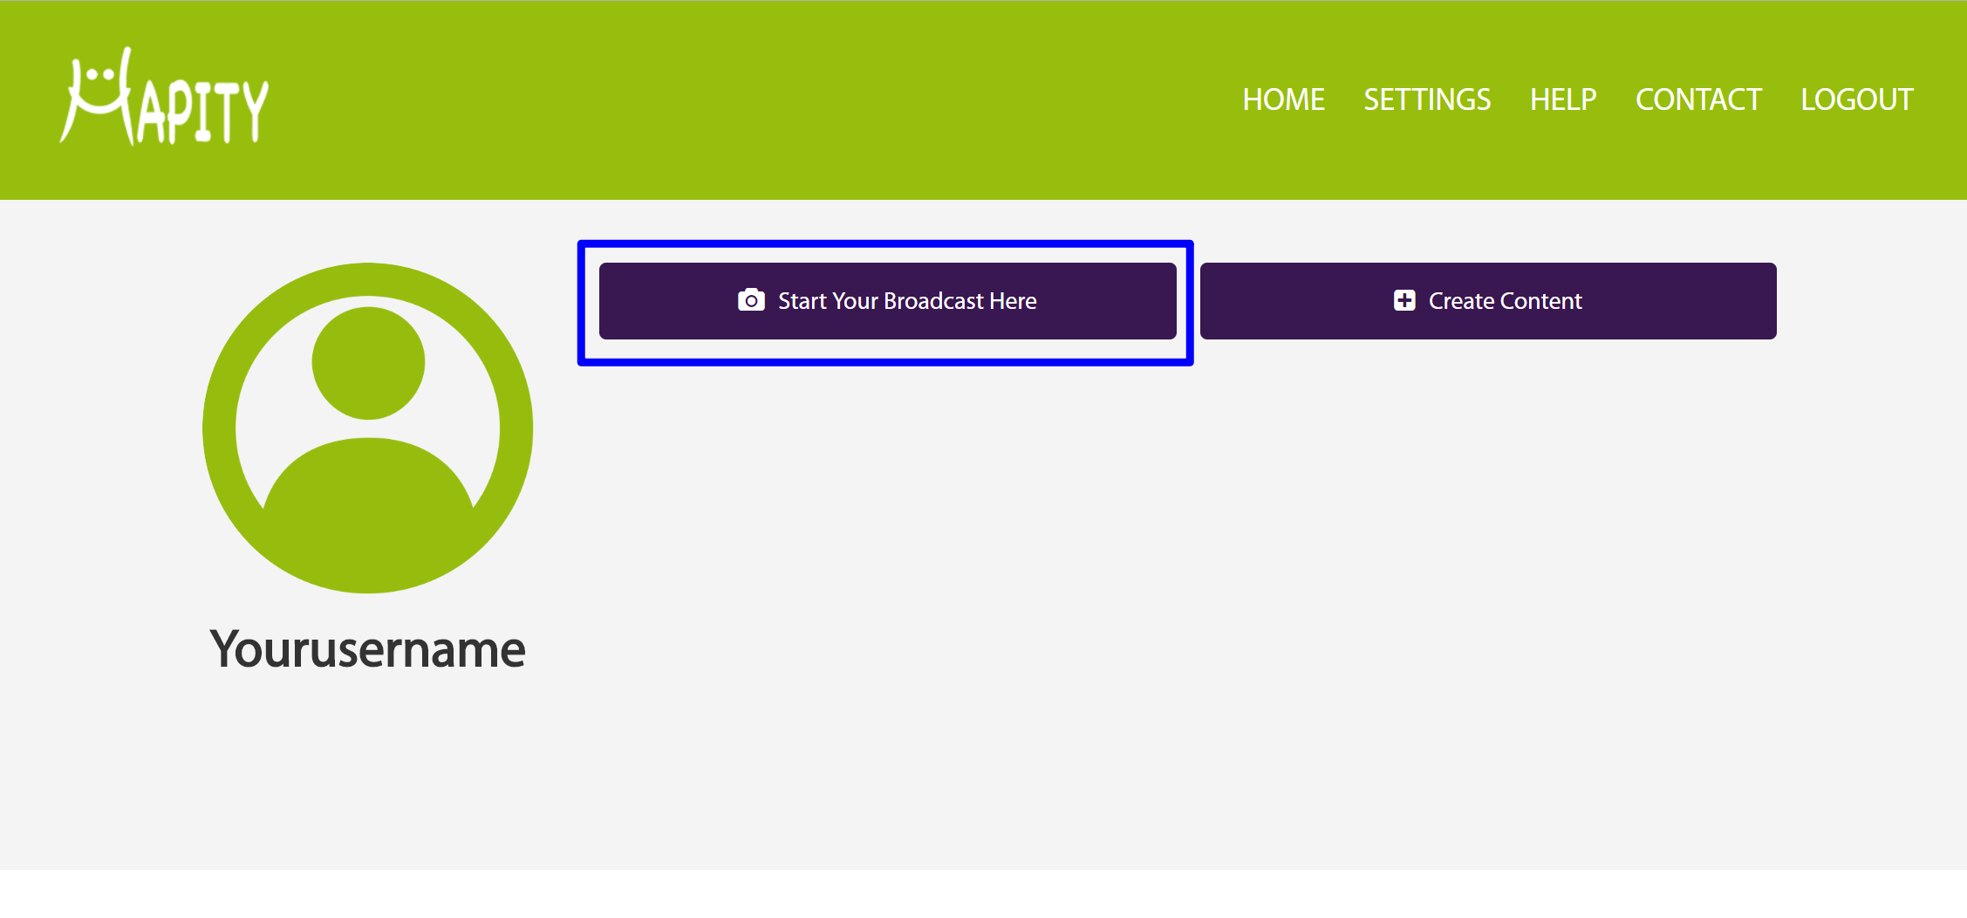

WordPress-8

Before you begin, you can give your broadcast an optional name and configure some other basic options. If you want to automatically add your live stream to your WordPress website, you should check the box for **Embed into website**.

When you're ready to begin your broadcast, click the **Start** button:

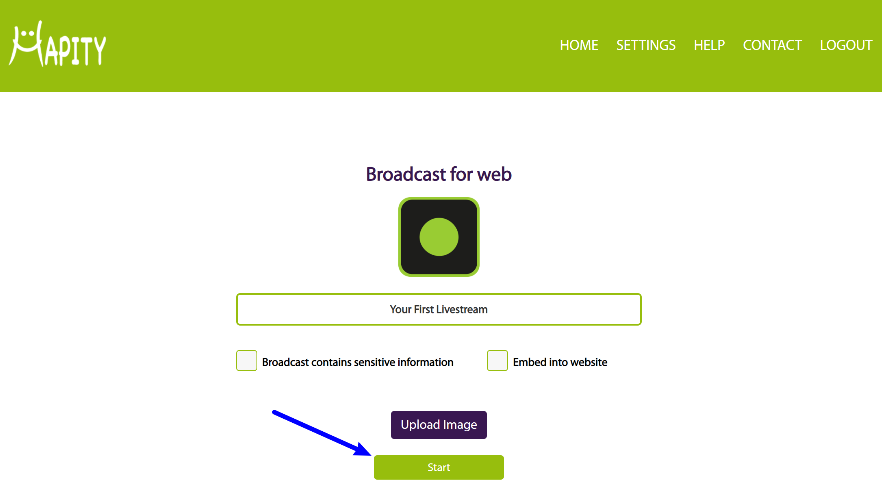

WordPress-9

Then, you'll see a prompt to give Hapity access to your computer's camera and microphone, which is necessary in order for Hapity to broadcast your content:

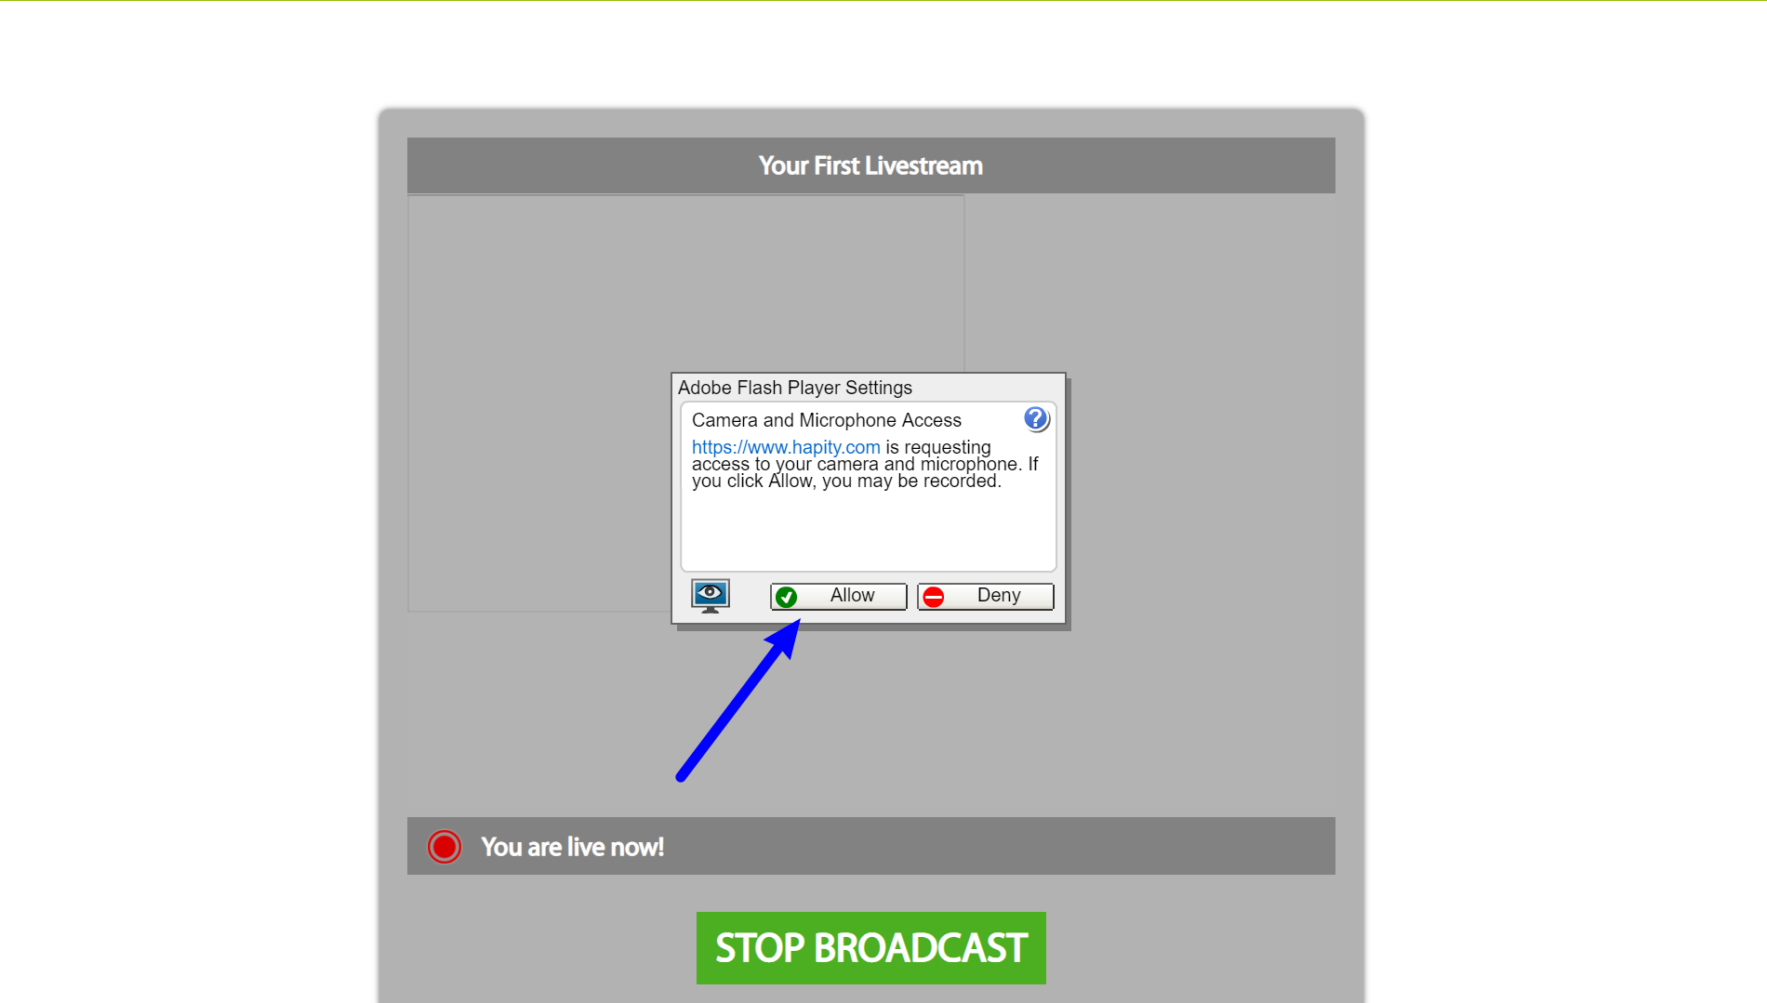

WordPress-10

Once you allow Hapity to have access to your camera and microphone, your broadcast is live. Say hello to your audience and have some fun!

You'll also see a live video feed of your broadcast, so you'll always know exactly what your visitors are seeing.

## Hapity Automatically Connects To Your WordPress Site

If you're broadcasting from a mobile app, or if you checked the box for **Embed into website** while broadcasting from your computer, your live stream will appear as the most recent post on the blog page of your WordPress site.

It will look like any other WordPress blog post:

* The post title is the name of your broadcast
* The post content contains the video player

While you're actively broadcasting, visitors to your site will be able to watch the live feed. After your broadcast is over, visitors will still be able to watch the full video replay at any point in the future:

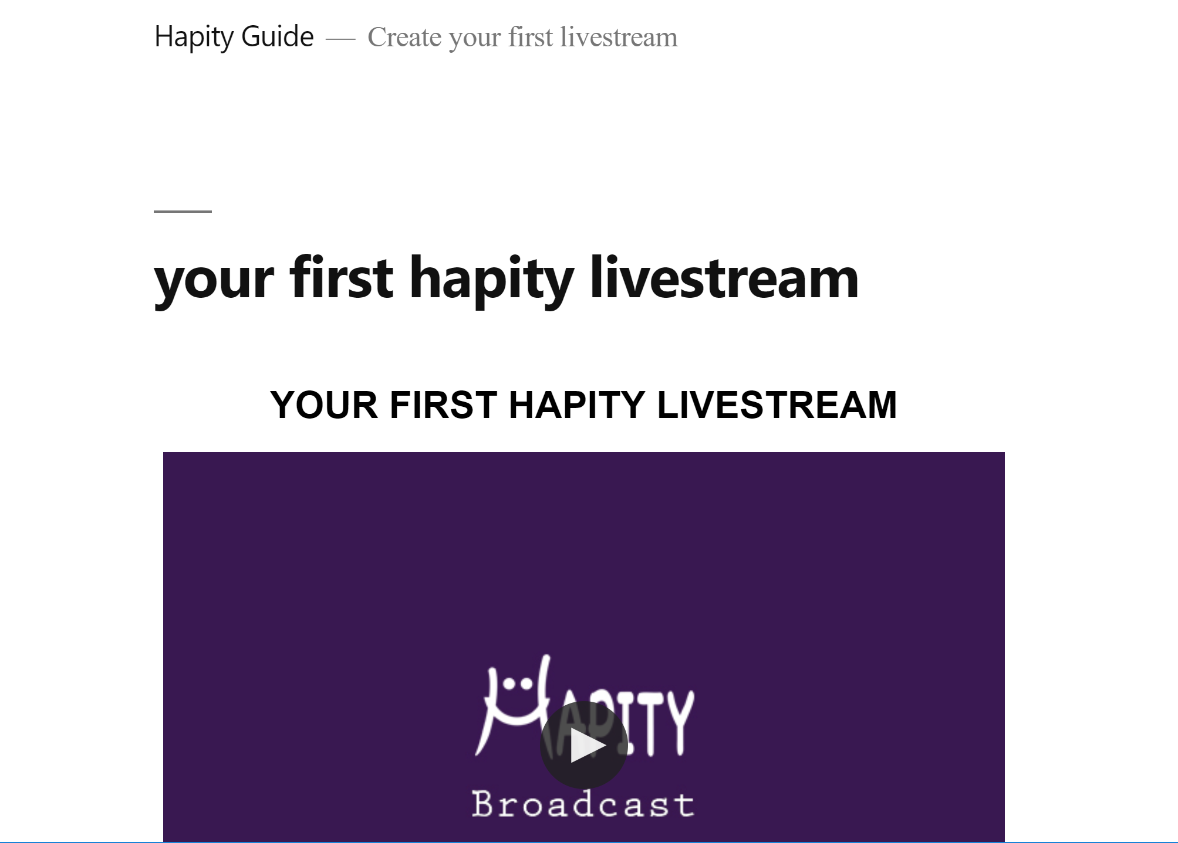

WordPress-11

Congratulations - you just created your first live broadcast with Hapity!